**MFL POLICY**

St Laurence in Thanet Church of England Junior Academy

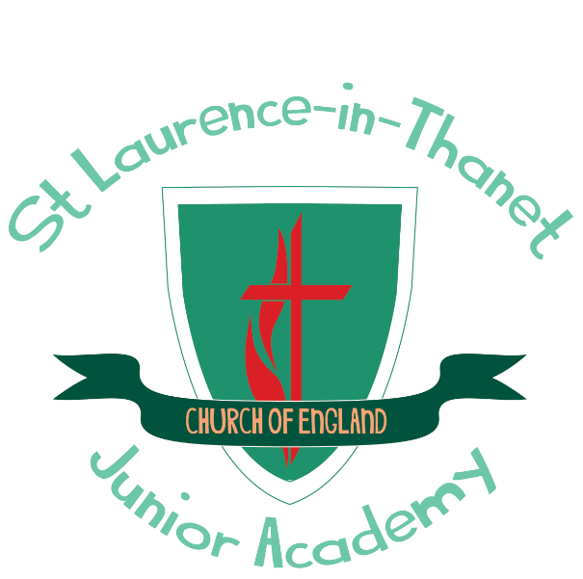

**Our school offers a supportive, inclusive, nurturing and inspiring learning environment, where each member is known, loved and**

**empowered to reach their full potential. Children are encouraged through an aspirational and engaging curriculum to develop their**

**knowledge, skills and character so that they can truly flourish, both now and in to the future.**

**“Believe Achieve Aspire!”**

|  |  |  |  |
| --- | --- | --- | --- |
| **Approved by:** | S. Graham |  | **Date:** April 2025 |
| **Last reviewed on:** | April 2025 |  |  |
| **Next review due by:** | April 2027 |  |  |

# Introduction

As part of a new primary National Curriculum, which took effect from September 2014, learning a Modern Foreign Language has become a requirement for children within KS2. At St Laurence, the language taught is French.

This policy has been written to take into account the new curriculum and has been agreed by staff and trustees.

# Our vision

Our vision is to promote a love of language learning; to provide an opening to other cultures, fostering curiosity and deepening our pupils’ understanding of the world. We strive to provide teaching that enables all children to express ideas and thoughts in another language, and to understand and respond to its speakers in both speech and writing.

# Aims

To provide a curriculum that enables all pupils to make progress in another language as well as provide enjoyment and challenge.

To develop children’s experience of language acquisition and encourage curiosity about languages.

To develop pupils’ understanding of what they hear and read, and have an ability to express themselves in speech and writing.

To extend their knowledge of how language works and explore differences between French and English.

To provide secure foundations for language learning at secondary school.

To develop a love of language-learning so that children choose to continue this learning further into their secondary years.

# Teaching and Learning Overview

Teaching is in line with the recommendations of the National Curriculum, with modifications in place which allow for the individual and differentiated needs of the children. It takes full account of the different experiences, strengths and interests of the children whilst also complying with the requirements and guidance on inclusion

*The National Curriculum for languages aims to ensure that all pupils:*

* *Understand and respond to spoken and written language from a variety of authentic sources*
* *Speak with increasing confidence, fluency and spontaneity, finding ways of communicating what they want to say, including through discussion and asking questions, and continually improving the accuracy of their pronunciation and intonation*
* *Can write at varying length, for different purposes and audiences, using the variety of grammatical structures that they have learnt*
* *Discover and develop an appreciation of a range of writing in the language studied.*

# Organisation

French is taught in a whole-class setting, by the class teacher or cover teacher.

Teachers follow the Rigolo Scheme of Work.

Children spend much of their time in language lessons speaking, listening and interacting. They take part in role-play, conversations, questioning and answering work, singing and recite. They play games and respond to short stories / film clips. Children are given opportunities to see and read vocabulary and when appropriate, children record written work either, informally, on whiteboards or on paper or within books. Each lesson is recorded in a Class Big Book.

Each class has a timetabled lesson each week for 3 terms per year. Language may also be revisited in short sessions throughout the week to consolidate knowledge and ensure new language is retained.

Below is an outline of the coverage using the Rigolo Scheme of Work:

|  |  |  |  |
| --- | --- | --- | --- |
|  | 1st unit | 2nd unit | 3rd unit |
| Year 3 | Rigolo 1 Unit 1 | Rigolo 1 Unit 2 | Rigolo 1 Unit 3 |
| Year 4 | Rigolo 1 Unit 4 | Rigolo 1 Unit 5 | Rigolo 1 Unit 6 |
| Year 5 | Rigolo 1 Unit 7 | Rigolo 1 Unit 8 | Rigolo 1 Unit 9 |
| Year 6 | Rigolo 1 Unit 10 | Rigolo 1 Unit 11 | Rigolo 1 Unit 12 |

# Resources

The Rigolo Scheme of Work is followed, through an interactive whiteboard–based resource, which includes a native speaker. Each teacher has the resources available on their laptop. Flash cards, worksheets and individual lesson plans can be printed from this, as needed, but teachers may prepare alternative / additional resources, if required, to meet the needs of their class.

The school has a range of additional resources which are available to all teachers. These are stored in the resource cupboard in the hall area.

# Record of children’s learning

Each lesson is recorded in a Class Big Book which becomes a portfolio of the children’s learning, these will move up through the school with the children and provide a record of their learning and progress. A lesson may be recorded within the Big Book in one of the following ways:

* A selection of children’s written work

(At least one higher achiever, one average and one lower achiever for that particular lesson. An expectation is that a wide range of children’s work is included; with the aim to ensure that all children will have work included at some time that year)

* Photos
* A pupil or pupils’, reflection on their learning that lesson
* A sentence by the Class teacher to summarise the learning that took place

Each child is provided with a *French Vocabulary Book,* in which they collect new vocabulary for each unit. This is kept throughout their time at St Laurence and becomes an effective resource in future lessons.

# Inclusion

In line with our inclusion policy, all children will have equal entitlement to language learning. For most of our children, language learning is a new experience and lessons naturally cater for this, taking into account a range of learning styles, enabling all children to feel success and achieve. However, children will continue to be provided with the individual tailored support they need as required.

# Assessment and record keeping

Informal assessment of progress will be made by the language provider during lessons through questioning and oral feedback. Individual progress is recorded three times per academic year. Children’s progress is recorded against each of the requirements from the Languages program of study in the National Curriculum.

# Monitoring and evaluation

The Subject leader, along with SLT, monitors the subject through planning and book looks as well as drop-ins and pupil consultations. The subject leader’s role includes supporting staff in the teaching of French; sharing good practice and development points through effective feedback, as well as providing a lead and direction for the subject.

Policy written by: Abigail Gasking

Policy written: April 2025

Review date: April 2027